A Project Report On

Lively Wallpapers

Submitted in partial fulfillment of the requirement for the award of the degree

Bachelor of Computer Application (BCA)

Academic Year 2022 – 23

Nitin Makwana 92200527107
Krunal Dabhi 92200527227
Fazal Kadivar 92200527221
Nevil Nandasana 92200527324

Internal Guide
Prof. Tirth Bhadeshiya



Rajkot-Morbi Road, At & PO : Gauridad, Rajkot 360 003. Gujarat. India.

Faculty of Computer Applications (FCA)



This is to certify that the project work entitled

Lively Wallpapers

submitted in partial fulfillment of the requirement for

the award of the degree of

Bachelor of Computer Application

of the

Marwadi University

is a result of the bonafide work carried out by

Nitin Makwana (92200527107)

Krunal Dabhi (92200527227)

Fazal Kadivar (92200527221)

Nevil Nandasana (92200527324)

during the academic year 2022-23

Faculty Guide |  | HOD |  | Dean

DECLARATION

I/We hereby declare that this project work entitled Lively Wallpapers is a record done by me.

I also declare that the matter embodied in this project is genuine work done by me and has not been submitted whether to this University or to any other University / Institute for the fulfillment of the requirement of any course of study.

Place :
Date :

Nitin Makwana (92200527107) Signature :
Krunal Dabhi (92200527221) Signature :
Fazal Kadivar (92200527221) Signature :
Nevil Nandasana (92200527324) Signature :

CONTENTS

Chapters | Particulars | Page No.
1 | SYNOPSIS
2  2.1  2.2 | PREAMBLE  General Introduction  Module description
3  3.1  3.2 | TECHNICAL DESCRIPTION  Hardware Requirement  Software Requirement
4  4.1 | SYSTEM DESIGN AND DEVELOPMENT  Menu Design & Screen Design
5  5.1  5.2 | TESTING  White Box Testing  Black Box Testing
6 | CONCLUSION
7 | LEARNING DURING PROJECT WORK
8  8.1  8.2 | BIBLIOGRAPHY  Online References  Offline References
–––
SYNOPSIS

A lively wallpaper website is a platform that provides users with a collection of high-quality wallpapers that they can use to decorate the backgrounds of their devices, such as desktop computers, laptops, tablets, and smartphones. These wallpapers are often organized into categories, such as nature, abstract, technology, sports, animals, and so on, to make it easier for users to find the type of wallpaper they are looking for.

In addition to browsing and downloading wallpapers, users may also be able to upload their own wallpaper designs to share with others. Some lively wallpaper websites may also offer customization options, allowing users to resize or crop wallpapers to fit their specific device's screen size and resolution.

Overall, a lively wallpaper website provides a convenient and visually appealing way for users to personalize the look of their devices with beautiful and inspiring images.

Preamble

2.1 General introduction.

Lively wallpapers is a lively wallpaper containing various wallpapers. It provides users to customise and design the UI of their devices to their liking.

2.2 Module description.

Lively Wallpapers is a website which enables the user to change their UI or theme on their mobile phones, laptops, desktops, or any of their devices. Lively Wallpapers offers a variety of images to choose from. That helps them to customize their devices to their liking.

As wallpapers are something which we can use to express the emotions like joy, sadness, loneliness,
A broken heart, feeling to stay alone or anonymous, some desires like a favourite car, food, place, etc.

Lively Wallpapers offers a variety of genres or categories to choose from. The categories involve.

1. Foods.
2. Travel.
3. Nature.
4. Animals.
5. Abstract.
6. Minimals.
7. Anime.
8. Red.
9. Black.
10. Drawings.
11. Games.
12. Logos.
13. Cars & Vehicles.
14. Technology.

The description of the above categories involves:-

1. Food

This category involves portrait and landscape pictures of delicious food and the various seasoning in food.

Various types of food pics for a foodie, who would love to have them on their desktop, laptop or mobile phone.

2. Travel

This category involves portrait and landscape pictures of places to travel Or quotes about travelling or some creative pictures of some famous places like 7 wonders of the world.

This category will be liked by various travellers who like to travel the world.

3. Nature

This category involves portrait and landscape pictures of the greenery, drone shots of the place we can’t ever imagine being in, some beautifully flowing rivers, some beautifully carved mountains etc.

This category will be liked by various naturalist who likes to be in touch with nature.

4. Animals

This category involves portrait and landscape pictures of beautiful animals that are wild or domesticated, who are captured by every risk that is taken by the photographers.

This category will be liked by various zoophilists, this category is a favourite for those who like the animals domestic or wild animals.

5. Abstract

This category involves the portrait and landscape pictures of the beautiful form of art known as abstract.
This is for those who loves to see art without judging it.
6. Minimals
This category involves the portrait and landscape pictures of the minimalist designs of logos.
This category is for those who like to keep everything simple and sweet for their wallpapers.
7. Anime
This category involves the portrait and landscape pictures of those who like anime, anime is a form of art that is formed by Japan this is read from the book named manga.
This is for those who like to live in their favourite worlds away from reality.
There are more of these exciting categories in the lively wallpapers. For those who love customizing their desktops or their mobile devices.

Technical Descriptions

4.1 Hardware Requirement

Processor | Intel Pentium 4 or later
Memory | 2GB, 4GB(recommended)
Screen resolution | 1280×1024 or larger
Application  Window size | 1024×680 or larger
Internet connection | Required

4.2 Software Requirement

Parameters | Windows | Mac
Operating system | Windows 8 | macOS  High Sierra 10.13
Browser | Chrome(4.0),Edge(9.0), Mozilla(3.0),Opera(10.1) or later. | Safari(3.2) or later
Algorithm and Flowchart

Load the web-site

Step-1 start
Step-2 send a request for loading the home page
Step-3 loaded the home page
Step-4 stop.

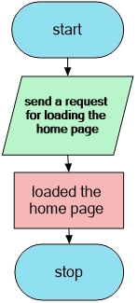

Searching of images.

Step-1: start.
Step-2: send a request for loading the home page.
Step-3: loaded home page.
Step-4: search for the category.
Step-5: locate the particular category in the server.
Step-6: load the category page for the server.
Step-7: stop.

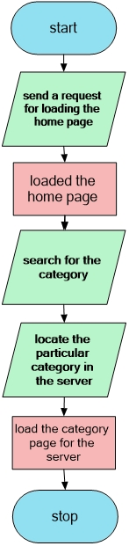

Go to the page.

Step-1: start.
Step-2: send a request for loading the home page.
Step-3: loaded home page.
Step-4: click on the next page button.
Step-5: request to load the next page from the server.
Step-6: load the next page.
Step-7: stop.

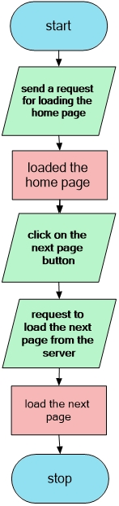

You click the “about us” button

Step-1: start.
Step-2: send a request for loading the home page.
Step-3: loaded home page.
Step-4: click on the “about us” button.
Step-5: request to load the “about us” form the server.
Step-6: load the “about us” page.
Step-7: stop.

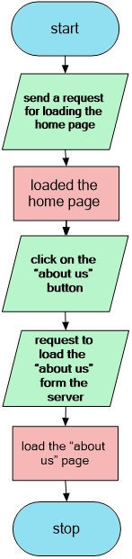

Menu and Screen design

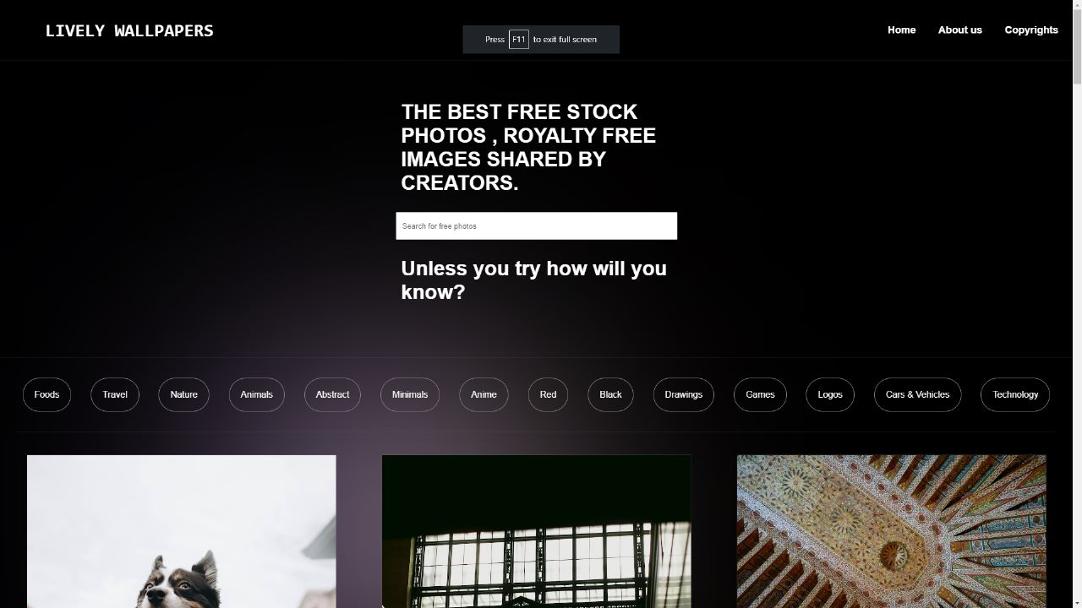
Menu and Screen design

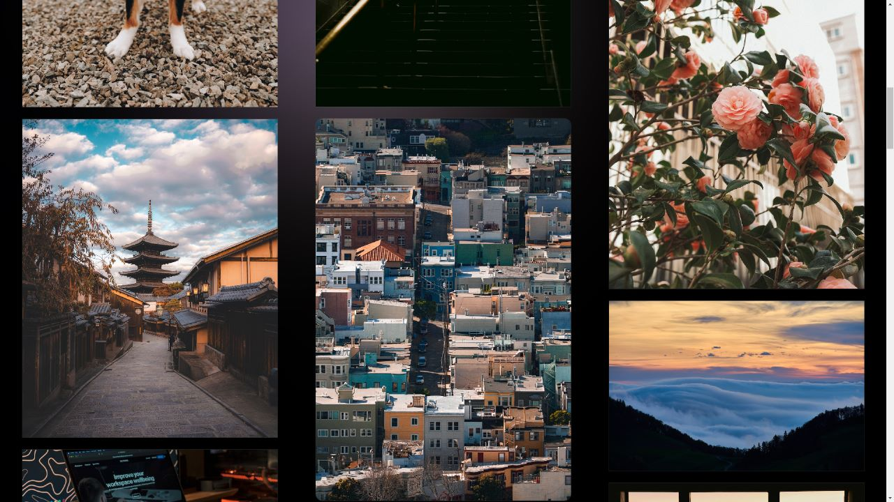
Menu and Screen design

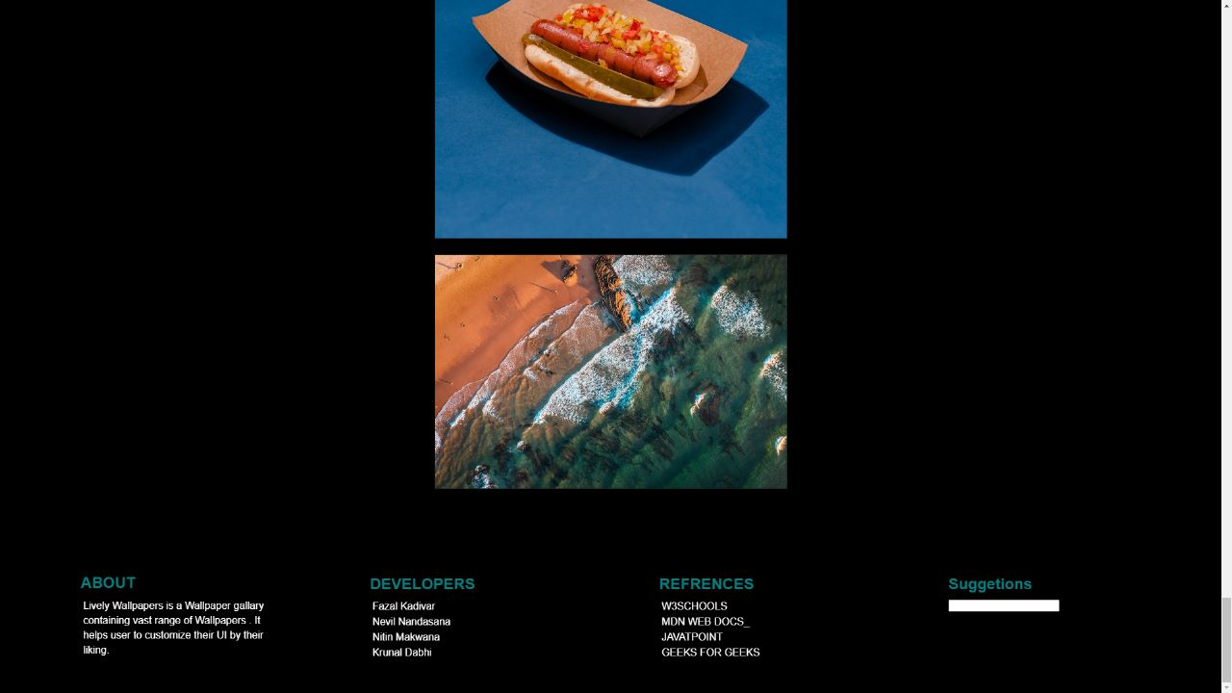

Testing
White Box Testing

White box testing, also known as clear box testing, is a software testing technique that involves testing the internal workings or code of an application or system.
In white box testing, the tester has knowledge of the internal workings of the software and is able to view and modify the source code. This allows the tester to design test cases that target specific areas of the code to ensure that they are working correctly.

White box testing can be used to test different aspects of the software such as code coverage, branch coverage, and path coverage. It can also be used to test specific functions or modules within the software.

Some common techniques used in white box testing include unit testing, integration testing, and regression testing. Unit testing involves testing individual modules or functions of the software, while integration testing involves testing how different modules or functions work together. Regression testing involves testing the software after changes have been made to ensure that existing functionality has not been affected.

Overall, white box testing is an important part of the software testing process as it can help to identify and fix issues early on in the development process, resulting in a more stable and reliable software product.

Black Box Testing

Black box testing is a software testing technique that involves testing the functionality of an application or system without having any knowledge of its internal workings or code.
In black box testing, the tester interacts with the software as an end user would, using various inputs and observing the outputs to ensure that the software functions correctly. This type of testing is focused on testing the software's behavior, functionality, and usability, rather than its internal code.

Black box testing can be used to test different aspects of the software such as functional testing, usability testing, performance testing, and security testing. Functional testing involves testing the functionality of the software against the requirements specification, while usability testing involves testing how easy it is to use the software. Performance testing involves testing the software's performance under various load conditions, and security testing involves testing the software for vulnerabilities and ensuring that it is secure from external threats.

Some common techniques used in black box testing include boundary value analysis, equivalence partitioning, and error guessing. Boundary value analysis involves testing the software using input values that are at the boundaries of acceptable values, while equivalence partitioning involves testing the software using input values that are representative of different groups of values. Error guessing involves testing the software using educated guesses about potential errors or faults that may occur.

Overall, black box testing is an important part of the software testing process as it can help to ensure that the software functions correctly and meets the requirements of the end user. It is particularly useful for testing software that is complex or has a large number of possible inputs or outputs.
Conclustion

In conclusion, our project successfully utilizes HTML, CSS, and JavaScript to create a dynamic and responsive web page. We began by designing the layout and structure of the page using HTML, then applied styling and formatting using CSS to make the page visually appealing and easy to navigate.

Overall, we believe our project demonstrates a solid understanding of the core web development technologies and their integration. We are proud of the final result and hope that it meets the needs of our intended audience. We also acknowledge that there is always room for improvement and look forward to receiving feedback and suggestions for future iterations of the project.

Learning During Project Work

If you're working on a lively wallpaper website project, there are several learning opportunities that you may encounter:
Website design: You may have the opportunity to develop your website design skills, such as selecting color schemes, choosing fonts, and designing layouts.
User experience (UX) design: A lively wallpaper website should provide an intuitive and enjoyable user experience. By working on this type of project, you can learn about UX design principles and how to create an engaging website that meets the needs of its users.
Web development: Developing a website involves using various programming languages, such as HTML, CSS, and JavaScript. You may have the opportunity to learn or improve your coding skills while working on a website project.
Search engine optimization (SEO): A website's visibility on search engines can be critical to its success.
By working on a website project, you can learn about SEO best practices, such as how to optimize website content and metadata to improve its ranking on search engine results pages.
Analytics: Website analytics can provide valuable insights into user behavior and website performance. By working on a website project, you can learn how to use analytics tools to gather data and analyze user behavior.

These are just a few examples of the potential learning opportunities that could arise from working on a lively wallpaper website project. The specific skills and knowledge you gain will depend on the nature of the project and your role within it.

Bibliography

8.1 Online Refernces

w3schools = https://www.w3schools.com/
stackoverflow = https://stackoverflow.com/
geeksforgeeks = https://www.geeksforgeeks.org/

8.1 Offline Refernces

HTML Black Book.
HTML and CSS: the complete reference,5th ed.
Microsoft Jscript, NET programing.

